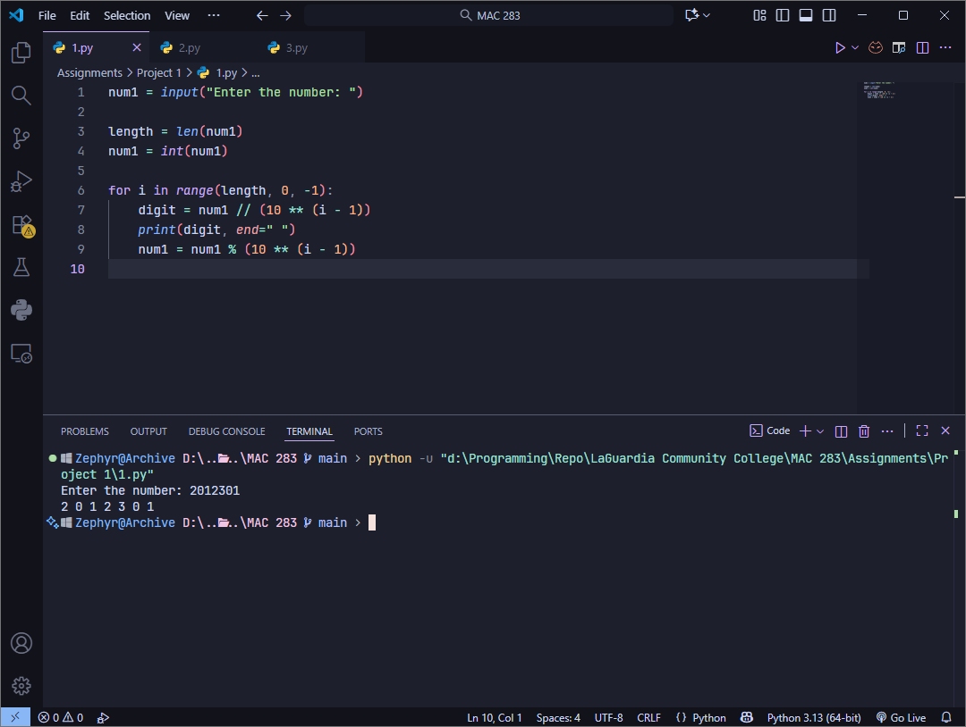
Question 1)

Problem description: Display each digit of a decimal integer “n” in base-10 separately
Example Input: 2012301
Example Output: 2 0 1 2 3 0 1
My screenshot includes, source code written in Python, and in the bottom the terminal shows my output.
Algorithm: I take the input number as string so that I can use the len() function to count how many digits there are. I convert the input to integer. Next I run a loop with range of digits recorded previously. Each digit is extracted using the calculation in “Line 7”. “Line 8” prints out the digit and adds a space instead of a newline so that the whole output comes in the same line separated by space. “Line 9” removes the currently printed number, using my example, after the first loop the variable “num1” changes from 2012301 to 012301. The loop keeps running until the conditions are met and we get the whole output.

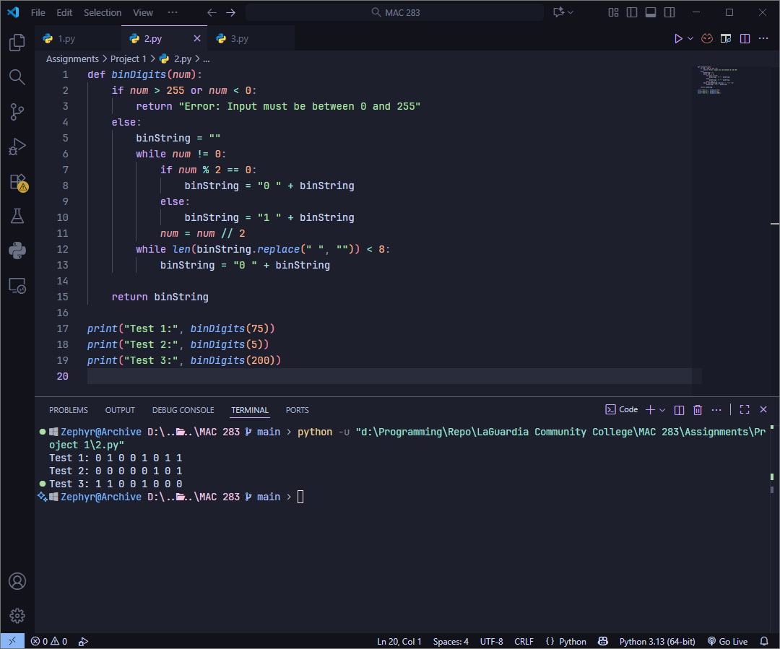
Question 2)

Problem: Display the 8-bit binary representation of a decimal integer n
Example Input (Test data): 75
Example Output: 0 1 0 0 1 0 1 1
My screenshot contains the source code and the terminal with the outputs from the test data. No input code was written as the question didn’t require it. However if needed I can add a
“usrinput = int(input(“Enter a number”))” and use “binDigits(usrinput)” to get the binary from the user data.
Algorithm: This function checks that the input number is within 0-255 which is the limit of an 8bit binary. The binary string is built by repeated division by 2 from “Line 6” to “Line 11”. After processing all bits, “Line 12 and 13” adds padding of 0s in case my output has less bits.

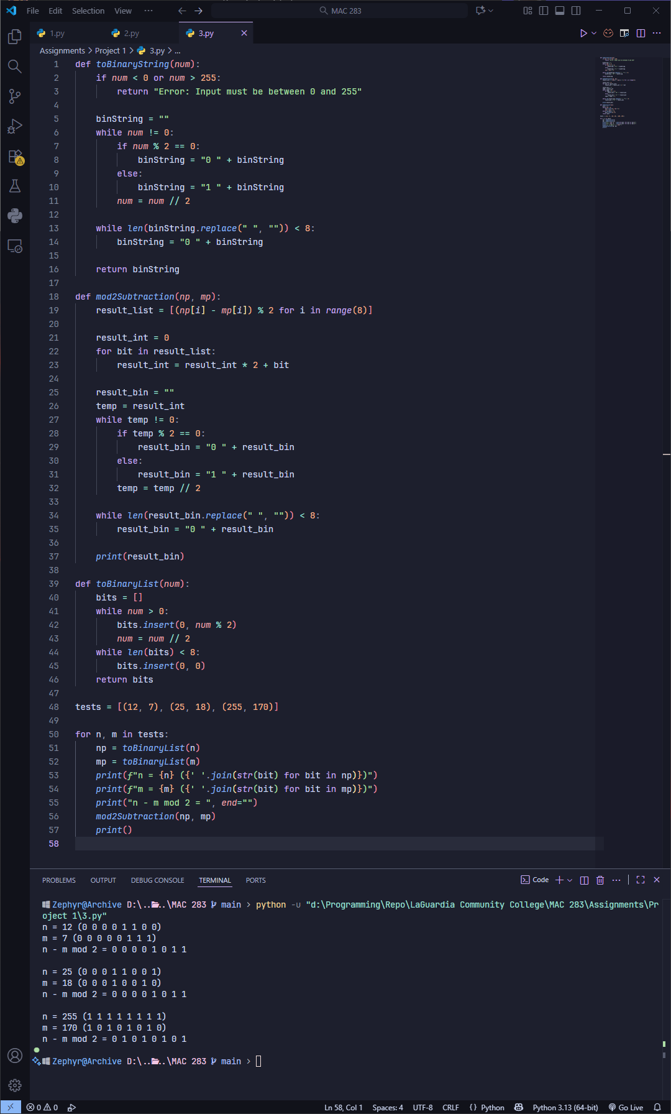

Question 3)

Problem: Design a function that displays the result of n – m in modulo-2 arithmetic.
Example Input (Test data): (12, 7)
Example Output: 0 0 0 0 1 0 1 1
Source code and outputs from test data are given in screenshot. I have not included user input again because the assignment didn’t ask for it.
Algorithm: Modulo-2 arithmetic is basically XOR gate. So I basically used a similar logic to question 1 and question 2 to convert to binary and separate the digits. The only new logic I added was to do the XOR calculation. In “Line 18” the function “mod2subtraction” compares each corresponding bit from both values and calculate the output.

